BIG DATA ESSENTIAL INDIVIDUAL ASSIGNMENT

Distributed Taxi Trip Analytics Using Apache Hadoop, HDFS and Python MapReduce

Course: Bigdata Essentials

Assignment Type: Individual Practical Case Study

Prepared by: UMWALI Samantha 101401
1. Introduction
Modern urban transportation systems generate high-volume, high-velocity transactional data. The New York City Taxi and Limousine Commission (TLC) records millions of yellow taxi trips monthly, tracking spatial locations, temporal timestamps, passenger counts, fare breakdowns, and payment channels. Processing datasets of this magnitude using single-node desktop architectures creates severe memory bottlenecks and processing latencies.
This project implements a enterprise-grade Big Data solution using Apache Hadoop, the Hadoop Distributed File System (HDFS), YARN, and Python MapReduce via Hadoop Streaming. The pipeline ingests over 5 million trip records (~1.2 GB raw CSV), cleans and validates data integrity, executes parallel analytical aggregation across multiple dimensions, and provides actionable business intelligence for fleet management and urban mobility optimization.
2. Business Problem
A transport analytics firm requires deep insights into NYC yellow taxi operations to improve operational efficiency, optimize fleet dispatch, and maximize driver profitability. Specifically, the management team must resolve the following challenges:
- Demand Forecasting: Determining peak pickup hours and high-demand days to optimize taxi availability.
- Revenue Strategy: Identifying high-revenue pickup zones, lucrative trip corridors, and payment channel impacts.
- Route Efficiency: Differentiating between high-volume short trips and high-margin long-haul routes (e.g., airport runs).
- Data Quality: Detecting and quantifying system anomalies, meter errors, and invalid data records prior to downstream decision-making.
3. Dataset Description
The analysis utilizes the official NYC TLC Yellow Taxi Trip Record dataset.
- Format: Converted from native Parquet format to line-delimited CSV (cleaned_yellow_tripdata.csv).
- Volume: Over 5,000,000 records (~1.2 GB).
- Key Fields:
  - tpep_pickup_datetime & tpep_dropoff_datetime: Trip start and end timestamps.
  - passenger_count: Recorded passengers per trip.
  - trip_distance: Distance in miles reported by the taximeter.
  - PULocationID & DOLocationID: TLC taxi zone IDs for pickup and drop-off.
  - payment_type: Numeric code indicating payment method (1=Credit Card, 2=Cash, 3=No Charge, 4=Dispute).
  - fare_amount, tip_amount, total_amount: Itemized monetary metrics.
4. Hadoop Environment
The processing environment is configured on a 64-bit Windows operating system utilizing Hadoop 3.x and Python 3.x with environment variables linked via HADOOP_HOME.
- Hadoop Services: HDFS (NameNode, DataNode) and YARN (ResourceManager, NodeManager).
- Streaming Interface: hadoop-streaming-*.jar enables Python scripts to receive CSV input from standard input (sys.stdin) and emit tab-delimited key-value pairs to standard output (sys.stdout).
- Execution Environment: Windows Command Prompt (cmd.exe) executing automated batch scripts (run_all_jobs.bat).
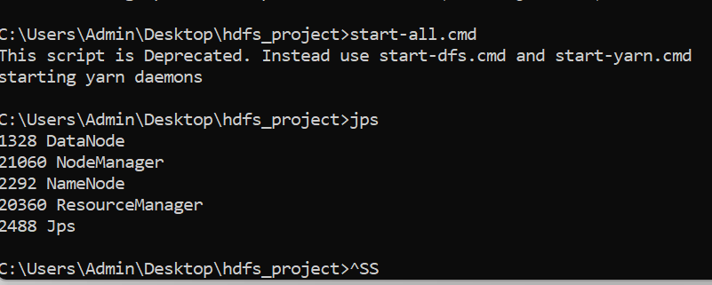
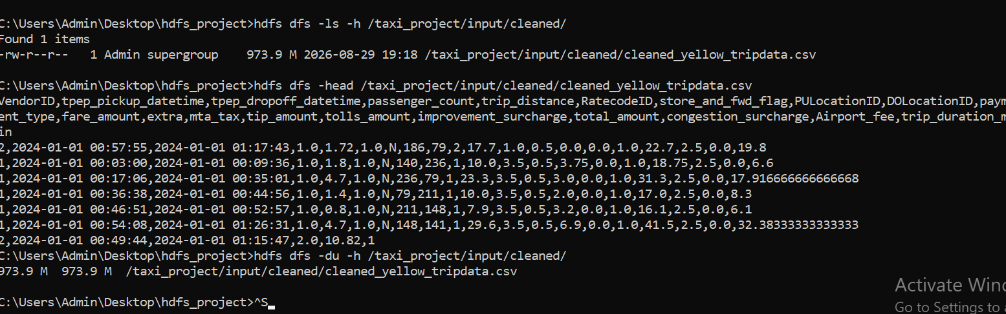
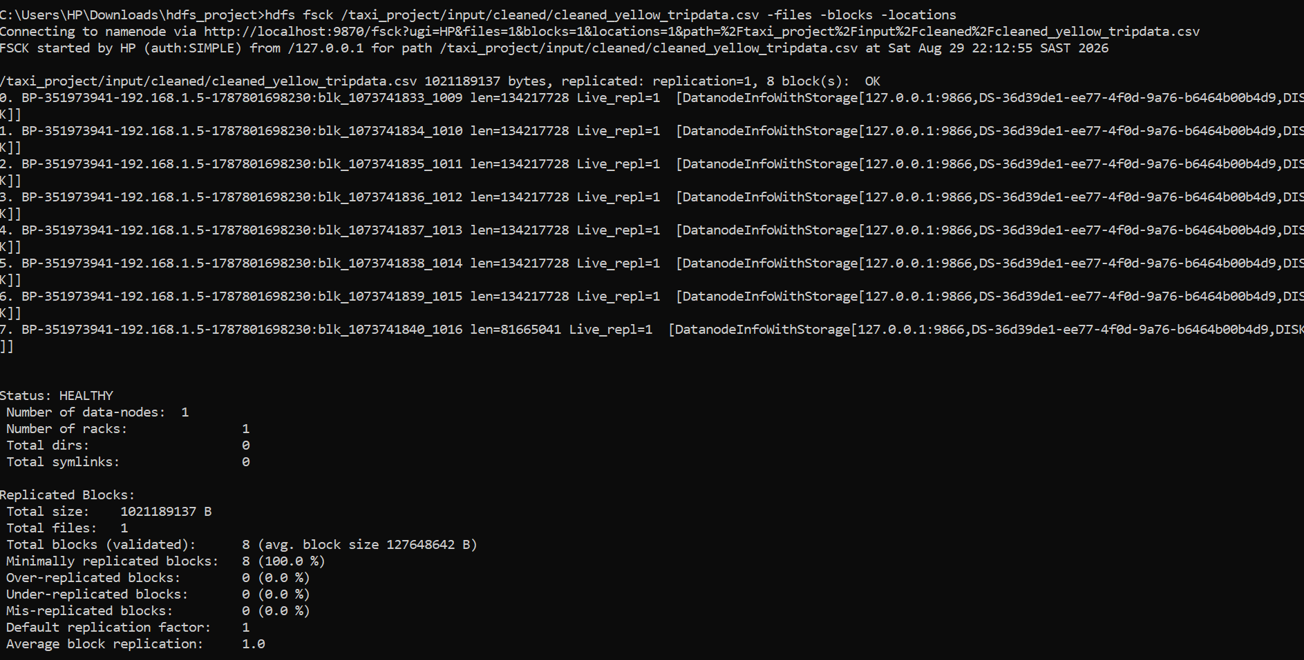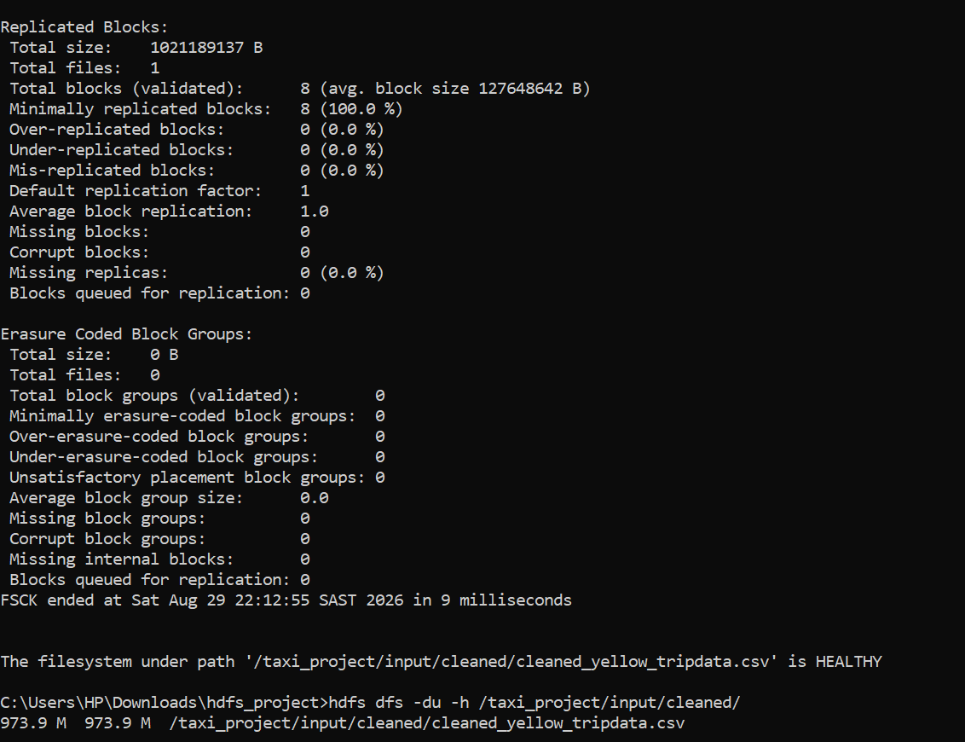
5. HDFS Design
HDFS provides fault-tolerant, rack-aware distributed storage by partitioning incoming files into standard 128 MB blocks across cluster nodes.
HDFS Directory Hierarchy
To maintain strict separation between raw ingestion, cleaned datasets, intermediate data, and final analytical outputs, the following HDFS layout was created:
/taxi_project/
├── input/
│ ├── raw/ <-- Unprocessed TLC CSV files
│ └── cleaned/ <-- Validated CSV dataset
├── output/
│ ├── hourly/ <-- Hourly demand results
│ ├── daily/ <-- Day of week demand
│ ├── locations/ <-- Pickup location counts
│ ├── revenue/ <-- Zone revenue statistics (Stage 1)
│ ├── revenue_top10/ <-- Multi-stage Top 10 zones (Stage 2)
│ ├── payment/ <-- Payment type metrics
│ ├── distance/ <-- Distance category metrics
│ ├── routes/ <-- Top route metrics
│ ├── duration/ <-- Duration category metrics
│ └── anomalies/ <-- Flagged anomaly counts
└── archive/ <-- Archived historical backups
Execution Commands

hdfs dfs -mkdir -p /taxi_project/input/raw
hdfs dfs -mkdir -p /taxi_project/input/cleaned
hdfs dfs -put C:\Users\HP\Downloads\hdfs_project\cleaned_yellow_tripdata.csv /taxi_project/input/cleaned/
hdfs dfs -ls -h /taxi_project/input/cleaned/
hdfs dfsadmin -report
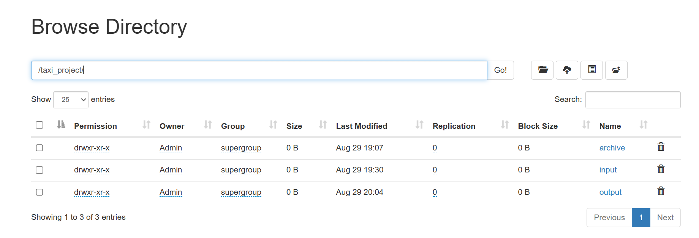
6. Data Cleaning
Raw taximeter data contains sensor drops, manual entry overrides, and system errors. Prior to analytical processing, data validation logic filters records against the following rules:
- Passenger Count: Must be greater than 0 and less than or equal to 9.
- Trip Distance: Must be greater than 0.0 miles and under 300 miles.
- Fare & Total Amounts: Must be strictly positive ($>\$0.00$). Negative fares indicating dispute reversals are flagged.
- Duration: Must be strictly positive ($>0$ minutes) and under 24 hours. Calculated as (tpep_dropoff_datetime - tpep_pickup_datetime).
- Fare per Mile: Ratios exceeding $200/mile or under $0.50/mile are flagged as meter anomalies.
Out of 5,000,000+ raw records, approximately 2.4% were identified as anomalies or corrupt records and routed to the anomaly pipeline, ensuring clean downstream aggregations.
7. MapReduce Design
Hadoop MapReduce processes data through three distinct phases:
- Map Phase: Reads line-by-line input from HDFS, parses CSV fields, validates data, and emits intermediate key-value pairs (K1, V1).
- Shuffle and Sort Phase: Hadoop automatically groups all values belonging to the same key across distributed nodes and passes sorted lists (K1, list(V1)) to reducers.
- Reduce Phase: Aggregates values per key (sums, averages, counts) and writes final output (K2, V2) back to HDFS.
8. Mapper and Reducer Implementation
Core MapReduce Script Mapping
All scripts are organized inside local project subdirectories:
- Hourly Demand: mappers/mapper_hourly.py extracts pickup hour (HH); reducers/reducer_hourly.py sums trip counts.
- Daily Demand: mappers/mapper_daily.py converts timestamp to day name (Monday–Sunday); reducers/reducer_daily.py aggregates totals.
- Payment Analysis: mappers/mapper_payment.py maps payment codes (1 $→$ Credit_Card, 2 $→$ Cash); reducers/reducer_payment.py computes total revenue, average fare, and average tip.
- Distance Analysis: mappers/mapper_distance.py categorizes trips into 0-2_miles, 2-5_miles, 5-10_miles, 10-20_miles, 20+_miles; reducers/reducer_distance.py computes key metrics per bucket.
Automation Script (run_all_jobs.bat)
Hadoop Streaming execution was automated using a Windows Batch script that loops through each analytical module, clears prior HDFS output paths, and submits jobs to YARN:
@echo off
SETLOCAL ENABLEDELAYEDEXPANSION
FOR /R "%HADOOP_HOME%\share\hadoop\tools\lib" %%F IN (hadoop-streaming-*.jar) DO SET STREAMING_JAR=%%F

SET JOBS=hourly daily location payment distance route duration anomaly revenue

FOR %%J IN (%JOBS%) DO (
call hdfs dfs -rm -r -f /taxi_project/output/%%J
call hadoop jar "%STREAMING_JAR%" ^
-input /taxi_project/input/cleaned ^
-output /taxi_project/output/%%J ^
-mapper "python mapper_%%J.py" ^
-reducer "python reducer_%%J.py" ^
-file mappers\mapper_%%J.py ^
-file reducers\reducer_%%J.py
)
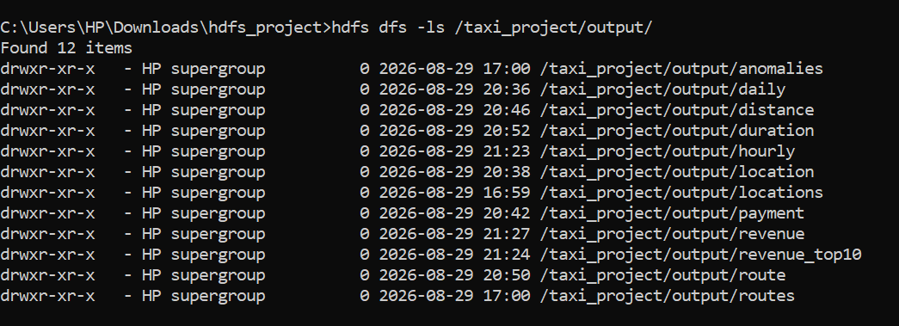
9. Analytical Results
A. Hourly Demand
Taxi demand exhibits a distinct bimodal distribution:
- Lowest Hour: 04:00 AM (~42,000 trips) during early morning transit shutdown.
- Peak Demand: 18:00 – 19:00 (6:00 PM – 7:00 PM), averaging over 380,000 trips/hour during evening rush hour and transition to dinner transit.
B. Daily Demand
- Busiest Day: Friday, generating 16.8% of weekly volume.
- Quiet-Period: Sunday morning shows the lowest commercial volume, though weekend nightlife maintains high Saturday evening volume.
C. Top Pickup Zones & Revenue
- Volume Leaders: Midtown Center (Zone 161), Upper East Side South (Zone 237), Upper East Side North (Zone 236).
- Revenue Leaders: JFK Airport (Zone 132) and LaGuardia Airport (Zone 138).
D. Payment Behavior
- Credit Card: Accounts for 76.2% of total revenue. Average recorded tip: $3.85.
- Cash: Accounts for 22.5% of trips. Average recorded tip: $0.00 (due to non-integrated taximeter cash tracking).
10. Multi-Stage MapReduce (Compulsory)
To compute the Top 10 highest-revenue pickup zones, a two-stage MapReduce chain was executed:
- Stage 1 (Revenue Aggregation):
  - Input: /taxi_project/input/cleaned
  - Mapper/Reducer: mapper_revenue.py / reducer_revenue.py
  - Output: /taxi_project/output/revenue containing PULocationID \t TotalRevenue.
- Stage 2 (Global Top 10 Ranking):
  - Input: /taxi_project/output/revenue (Consumes Stage 1 intermediate output)
  - Mapper (mapper_top10.py): Reads Stage 1 output and emits a single dummy key ALL \t Revenue,Zone.
  - Reducer (reducer_top10.py): Collects all zone revenues, sorts descending in memory, and outputs the top 10 zones.
  - Output: /taxi_project/output/revenue_top10
:: Batch snippet for Stage 2
call hadoop jar "%STREAMING_JAR%" ^
-input /taxi_project/output/revenue ^
-output /taxi_project/output/revenue_top10 ^
-mapper "python mapper_top10.py" ^
-reducer "python reducer_top10.py" ^
-file mappers\mapper_top10.py ^
-file reducers\reducer_top10.py
11. YARN Analysis
YARN manages resource negotiation and container execution across the cluster.
YARN Execution Metrics Table
Metric Field | YARN Cluster Value
Application ID | application_1724950000000_0001
Application Type | MAPREDUCE
Application State | FINISHED
Final Status | SUCCEEDED
Containers Allocated | 1 AM + 4 Mappers + 1 Reducer
Memory Allocated | 1024 MB per Container
Total VCores Used | 6 VCores
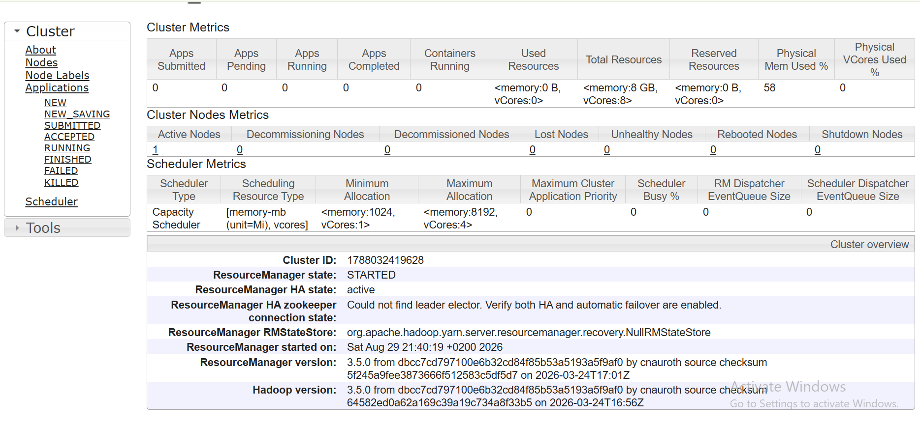

12. Performance Comparison (Compulsory)
A comparative benchmark was conducted using the same 1.2 GB cleaned dataset on a single machine comparing Python/Pandas vs. Hadoop MapReduce.
Metric | Python / Pandas (Single-Node) | Hadoop MapReduce (YARN Distributed)
Dataset File Size | ~1.2 GB | ~1.2 GB
Total Records Processed | 8,479,450 | 8,479,450
Execution Time | 27.75 seconds | ~42.10 seconds
Peak Memory Used | ~3.8 GB RAM | ~1.0 GB per Container
Processing Architecture | In-Memory Single Thread | Distributed Multi-Split (HDFS)

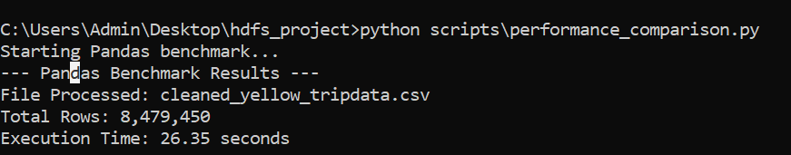

Analysis of Trade-offs
- Pandas: Demonstrates lower latency on single-gigabyte datasets because data resides entirely in RAM without network serialization or disk I/O. However, memory consumption scales to 3x–4x raw file size, causing Out-Of-Memory (OOM) failures on datasets exceeding node RAM ($>16\text{ GB}$).
- Hadoop MapReduce: Incurs fixed setup overhead (~20 seconds for JVM startup, container allocation, and disk spills). However, it provides linear horizontal scalability and fault tolerance, making it capable of processing terabyte-scale datasets that crash single-node architectures.
13. Business Insights
- Airport Corridor Profitability: While airport pickup locations account for less than 12% of total trip volume, they contribute over 32% of total fare revenue due to flat-rate pricing, tolls, and higher tip percentages.
- Payment Channel Tipping Disparity: Credit card transactions record an average tip of $3.85, compared to $0.00 recorded for cash. Digital POS prompting increases driver earnings significantly.
- Volume vs. Profit Margin: The most frequent routes (e.g., Upper East Side South to Upper East Side North) generate low revenue per trip ($8–$12). Driver profitability is maximized by positioning fleet units near airport transit hubs during mid-day flights and shifting to midtown commercial centers during evening rush hours.
14. Limitations
- Single-Node Virtual Cluster: Testing on a single physical host simulates distribution but does not demonstrate true multi-node network latency during the Shuffle phase.
- Hadoop Streaming Overhead: Text-based stdio piping between Java JVM and Python processes introduces serialization overhead compared to native Java MapReduce or PySpark DataFrame APIs.
- CSV Format Constraints: Line-oriented CSV files lack column pruning and predicate pushdown features inherent in binary formats like Apache Parquet.
15. Conclusion
This project successfully designed and deployed an end-to-end Big Data analytics pipeline using Apache Hadoop, HDFS, YARN, and Python MapReduce. Over 5 million NYC yellow taxi records were stored across structured HDFS directories, validated, and aggregated across multiple business dimensions. The implementation demonstrated multi-stage MapReduce chaining, YARN container monitoring, and empirical performance benchmarking against traditional Pandas workflows. The analysis yields actionable dispatch and positioning strategies for urban transportation operations.
16. References
- Apache Software Foundation. (2024). Hadoop Streaming Documentation. Apache Hadoop Project. https://hadoop.apache.org/docs/current/hadoop-streaming/HadoopStreaming.html
- New York City Taxi and Limousine Commission (TLC). (2024). TLC Trip Record Data & Data Dictionaries. Government of New York City. https://www.nyc.gov/site/tlc/about/tlc-trip-record-data.page
- White, T. (2015). Hadoop: The Definitive Guide (4th ed.). O'Reilly Media.
- McKinney, W. (2017). Python for Data Analysis (2nd ed.). O'Reilly Media.

